**Results 1**

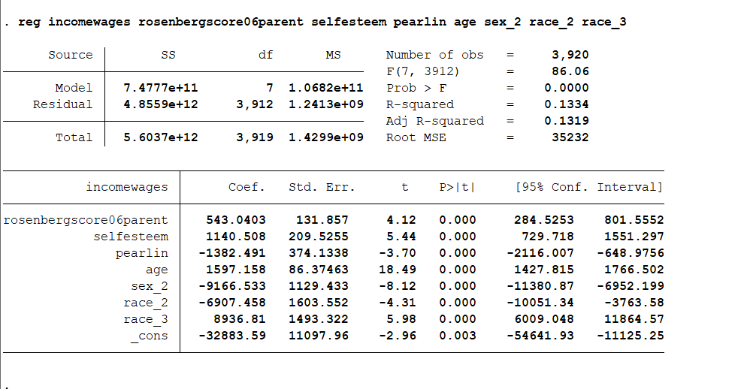

**Results 2**

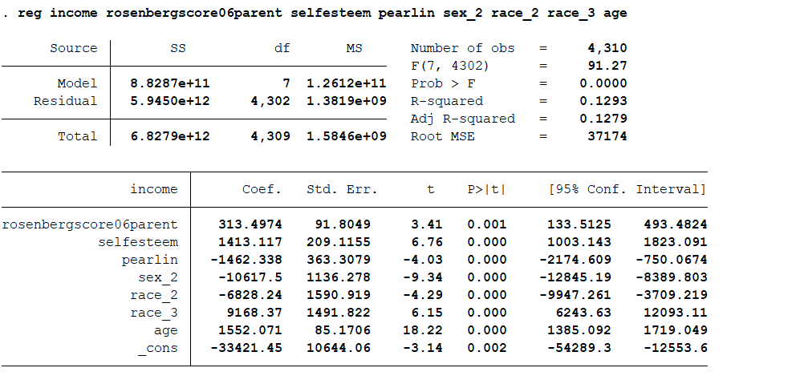

**Variables Description**

|  |  |
| --- | --- |
| **Variable Name** | **Description** |
| incomewages | TOT INCOME FR WAGES, SALARY, COMM, TIPS IN REF YR 2020 |
| income | incomebus(TOT INCOME FR OWN FARM OR BUS AFTER EXP IN REF YR 2020)+ incomewages |
| rosenberg06parent | ROSENBERG SELF-ESTEEM SCORE 06 2006 |
| selfesteem | selfestm1+selfestm2+selfestm3 selfestm4+selfestm5+selfestm6 selfestm7+selfestm8+selfestm9 +selfestm10(description available at childdata.dta)  selfestm3,selfestm5, selfestm8, selfestm9,selfestm10 are reverse coded i.e. 1 is mapped to 4, 2 to 3, 3 to 2 and 4 to 1 |
| pearlin | pearlin1+ pearlin2+pearlin3+pearlin4+pearlin5  +pearlin6+pearlin7 (description available at childdata.dta) |
| age | Age |
| sex_2 | Sex Female- 0 is no, 1 is yes. Coefficient is interpreted in terms of the times of impact sex-female has over male on income |
| race_2 | Race- Black |
| race_3 | Race: Non-Black and non-Hispanic |

**Mediation Analysis**

Partial mediation was found between child’s self-esteem and mother’s self-esteem (rosenbergscore06parent) to have an impact on income in wages. Significant correlation between IV (Independent Variable) and DV (Dependent Variable) was found initially. Subsequently, significant correlation between MV and IV was also identified. After that a multiple regression model with DV, IV and MV was conducted. IV still had a significant impact on DV but the coefficient was lower than before suggesting a partial mediation. It is to be noted that the impact of IV and MV has a low coefficient suggesting a weak correlation.   
(The mediation results are available in the folder)

Child’s Self Esteem

(Mediating Variable)

Mother’s Self-Esteem

(Independent Variable)

Income in Wages

(Dependent Variable)